Two Art Fellows in Barcelona and Beyond 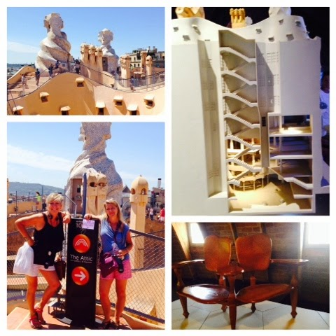
What happens when you combine an art teacher with a burning desire to re-visit an architectural “wonder” that has changed considerably since her last visit over 30 years ago + good friends who love to travel and learn together + a grant source that makes dreams for teachers to design their own professional development opportunities become reality? ANSWER: Being granted a Fund for Teacher’s Fellowship! Lauren Fowler and Gaile Randall did just this in order to research the lives and work of unconventional artists in the Catalan region of Spain and France to inspire innovation and promote problem solving solutions for open-ended, student centered curriculum to be written upon their return. Two sessions will be offered at this year’s AAEA Conference: The process of grant writing will be discussed in a group presentation along with Sharon Christman and Beelee Tullos, and a hands-on lesson based on the work of Gaudi and curriculum guide that is based on the research gained through our research.
Throughout year and into the future, Gaile and Lauren will be collaborating with Petra Vlasman our new friend and art educator from the Gala Salvador Dali Foundation to develop lessons based on the life and work of Dali. We will include brief synapsis of these in our upcoming newsletters, and we will add them onto our blog http://laurenandgaile.blogspot.com

Thank you Fund for Teachers and Alabama Public Television for making our granting our dreams!

