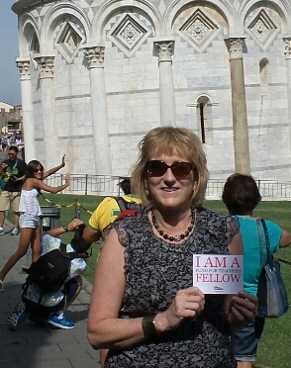
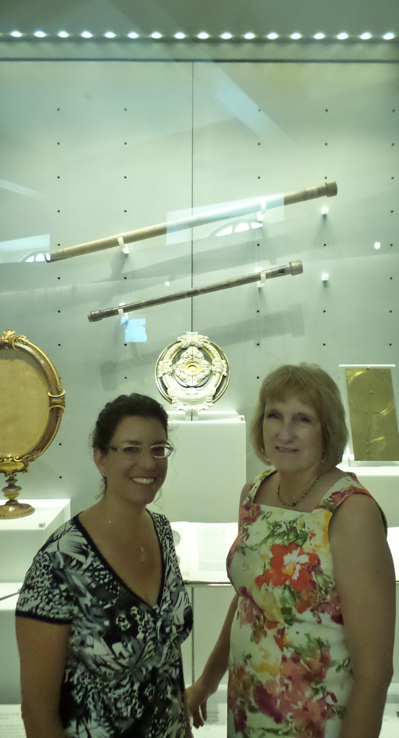
Standing in front of Galileo’s telescopes in the Museo Galileo

Fund for Teachers gave me the opportunity to spend 10 days in Italy researching the details of Galileo’s complex and at times turbulent life, actually seeing and studying his inventions up close, and discovering how the culture of the Renaissance dramatically affected his world. I came back having learned so much more than I had expected and am now eager to share what I learned with my students and with other teachers. I want to thank Fund for Teachers for giving me this wonderful professional development experience. As the Italians say, “Mille grazie!”

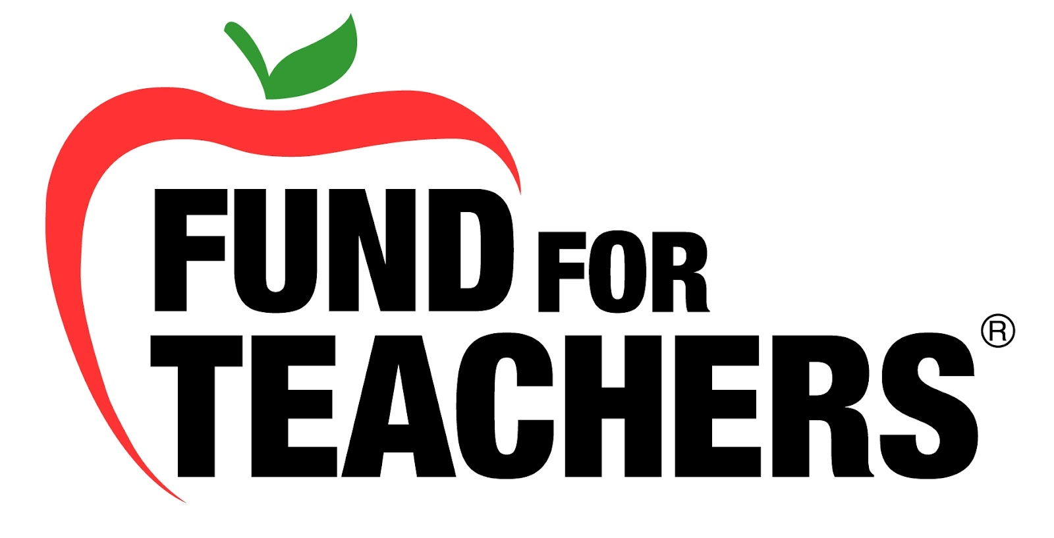
JJune, 2014
Rebecca Becnel
Saraland High School
, Saraland, AL 36571
rbecnel@saralandboe.org
www.searchingforgalileo.com

Galileo
Searching for Galileo
All truths are easy to understand once they are discovered; the point is to discover.
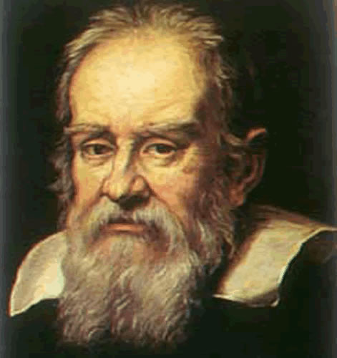
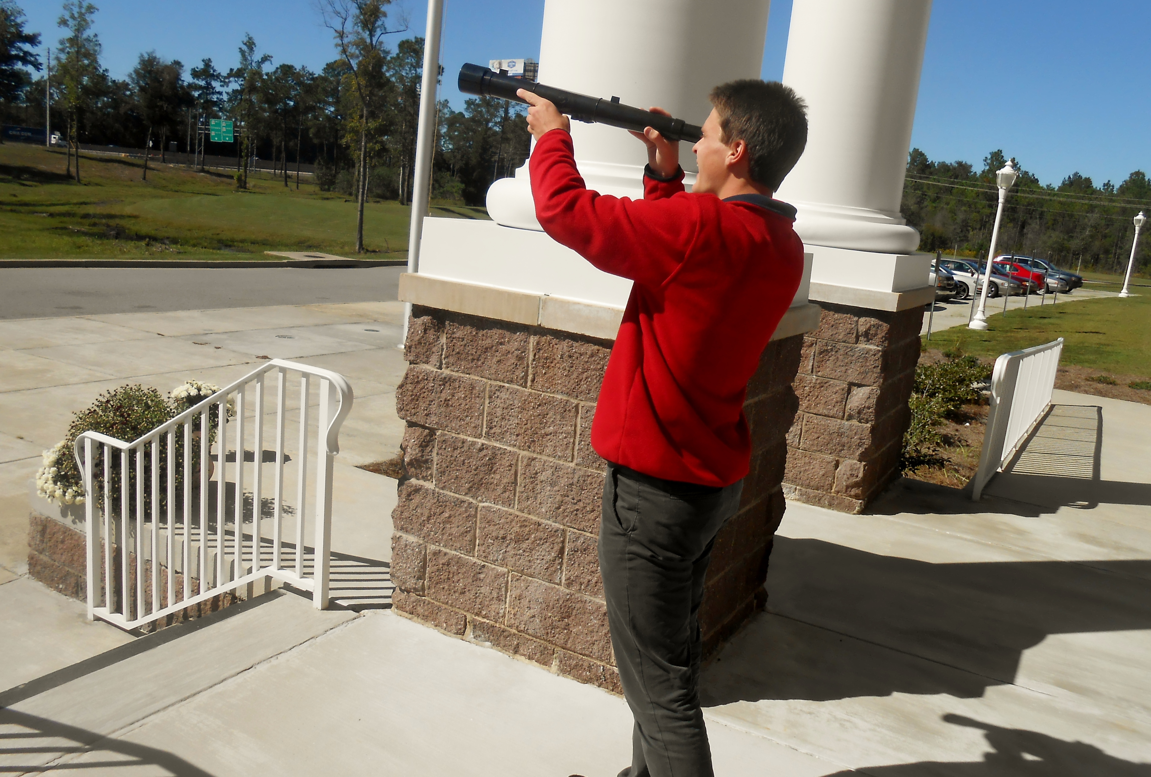
My student using his Galileoscope.
Fund for Teachers .
300,000
100,000
2004 2005 2006 2007 2008

